Case 0 : ----- when A = 0v and B=0v ---- op is 0v

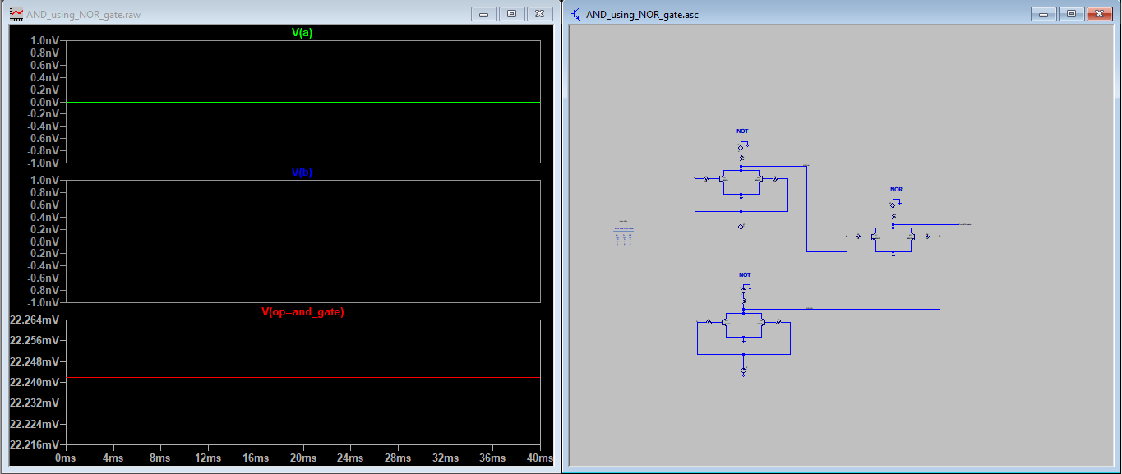

Case 1 : ----- when A = 0v and B=5v ---- op is 0v

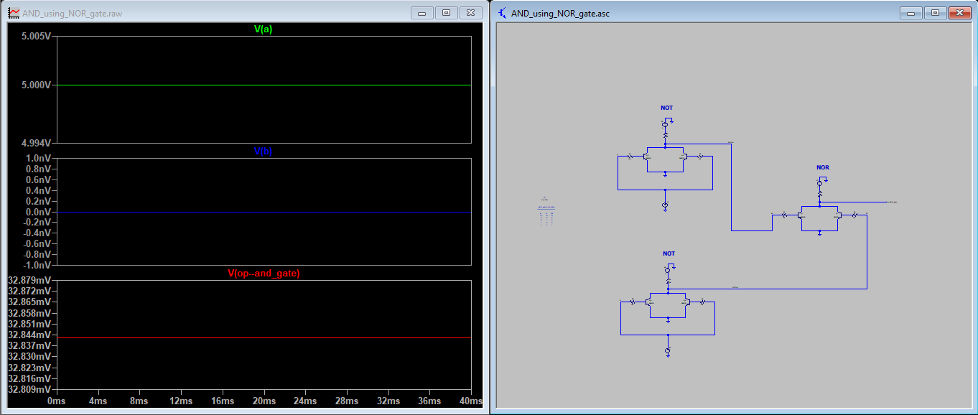

Case 2 : ----- when A = 5v and B=0v ---- op is 0v

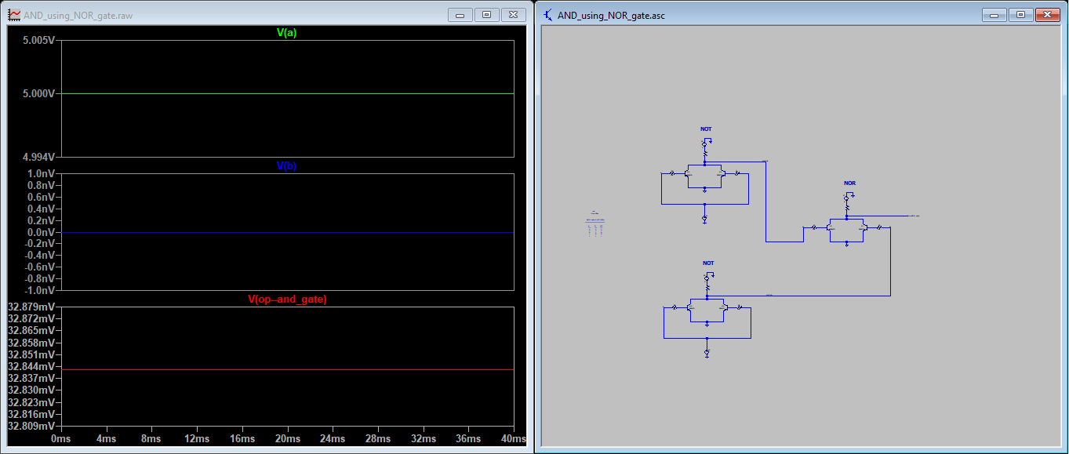

Case 3 : ----- when A=5v and B=5v ---- op is 5v

